AI-ENABLED WATER WELL PREDICTOR

Boya Valmiki Karthikeya
kkarthikeya27h@gmail.com
Sannapareddy Manohar Reddy
reddymanohar883@gmail.com
T N Kushal
kushaltn7@gmail.com
Deepthi S
deepthi.s@presidencyuniversity.in

School of Computer Science and Engineering, Presidency University, Bangalore, India

Abstract— Water is a basic necessity, but it is the reason why millions of people continue to face difficulties in accessing clean and readily available freshwater. Groundwater wells continue to be one of the most reliable water sources in rural and semi-urban areas, but the location choices are usually based on the guesswork or a narrow understanding of local area, which results in the failure of the endeavour and financial loss.
In this paper, we presents an AI-Based Water Well Predictor, a machine intelligent system that uses machine learning to predict the presence of groundwater and to make an optimal choice of the drilling location. The model incorporates several data sets - including the geological structure, soil properties, rainfall and past well performance - to provide an estimate of the probability of productive wells. Random Forest, Support Vector Machines and Neural Networks algorithms are used to identify spatial and environmental values, which are positive indicators of the presence of groundwater. The system also produces user-friendly visualizations including heatmaps and spatial potential maps to aid in making wise decisions. Integrating artificial intelligence with the principles of sustainable water-resource management, the offered solution will provide a more precise, understandable, and transparent framework of better groundwater exploration and long-term water security.
Keywords: Artificial Intelligence, Machine Learning, Groundwater, Water Well, Prediction, Random Forest, Regression, Classification, Streamlit, NAQUIM, Water Management, Decision Support System.

- INTRODUCTION
Water is not only a natural resource but it is life itself. Well-derived groundwater is to the millions of the world, both rural and semiarid, the most reliable source of drinking water, farm irrigation, and a regular income. Nonetheless, the location of wells that are to be drilled to a productive well is also a major challenge. Communities will justifiably spend little financial resources in drilling only to find dry or unproductive wells. This not only ensured that the money and the energy went to waste but also entrenched the water security crisis. Traditionally, groundwater exploration is based on by-hand survey, local knowledge or geophysical surveys. Though usually effective, they are expensive, time-prohibitive and usually unavailable to the most vulnerable communities. As swiftly changing climatic conditions, growing populations, and dwindling water supplies on the ground remain unsolved, the demand to have smarter, more efficient, and easily accessible tools has never been higher. The Water Well Predictor that employs AI to predict groundwater seeks to address this gap and introduce the power of AI into the groundwater prediction world. Through processing large volumes of data such as the soil characteristics, rainfall and the land use, the history of the well performance - AI models reveal latent trends that are sometimes elusive to the human race. These will be able to inform communities and decision makers on the most suitable places to drill wells.
The strength of such a method is not only the accuracy but also usefulness. Having user friendly tools and visualization, the system will enable the farmers, local government, and the NGOs to make rational choices on how to use the groundwater. More to the point, the project is planned to be sustainable-it will enable the communities to manage the wells in a responsible way and preserve the water resources and use them in the future. Essentially, this project goes well beyond a technological breakthrough-it is a statement toward the time when access to water would no longer be a case of chance but one of wise, science-based choices. Bringing together the needs of humans and the brains of machines, the AI Water Well Predictor promises to turn water access into a more consistent and sustainable reality.
- LITERATURE SURVEY
Kun Chen [1] Chen et al. (2022) proposed the integration of SBASInSAR–based vertical deformation into the NASA Catchment Land Surface Model to improve the estimation of terrestrial water storage. Their study demonstrated that data assimilation methods provided an enhanced temporal resolution from a month to 12 days and reduced estimation errors compared to GRACE-only methods. Gabriela May-Lagunes [2] May-Lagunes et al. (2023) used machine learning techniques in order to forecast the levels of groundwater in California's Central Valley, which has been highly dependent on aquifers for agriculture. The time series, ensemble, and deep learning models were tested, and it was realized that XGBoost outperformed others with a 3-month forecasting horizon. Results indicated that well-specific features and seasonal patterns were more predictive than exogenous climate factors, followed by the capability of ML in sustainable groundwater management. Seung-Bum Kim [3] Grounds from previous studies indicate that L-band SAR can retrieve the moisture of the soil under forests, although some challenges have caused limitations due to the attenuation effect of the canopy, the variety of species, and effects related to terrain. Missions such as SMAP were able to provide information at coarse resolution, although airborne experiments, like that of SMAPVEX12, documented the feasibility of finer-scale retrieval. Consequently, Amirhosein Mosavi [4] The geochemical, geostatistical, and statistical models traditionally adopted for the prediction of groundwater salinity lack accuracy and generalization in many cases. Recently, ANN and SVM AI techniques showed superior performance. However, applications remain minimal. Naeem Iqbal [5] Earlier research on GWL prediction using statistical approaches, such as regression and ARIMA, was not helpful in coping with nonlinear hydrogeological variability. Soft computing models such as ANN, SVM, and ANFIS also improved accuracy but remained sensitive to complex groundwater dynamics. Recent approaches towards ensemble methods, for instance, Random Forest, provided better generalization, though single models issues persisted in noisy borehole data. Bilal Aslam [6] The conventional WQI and physicochemical approaches, though widely adopted for the assessment of water quality, have limited adoptive efficiency. Machine learning coupled with the technique of data mining resulted in the improvement of predictive capability. However, issues in generalization were noted in single models. This paper focused on the advancement of previous studies through the introduction of a hybrid ML-DM indexing framework as an alternative approach towards more robust and reliable water quality management. Fan Feng [7] Traditional hydrogeological and statistical GWP mapping of the complex factors tends to have no capability to model factors This experiment significantly advances previous projects through the use of high-quality modeling in terms of groundwater potential volumetric mapping using testable ML and ensemble tools. Eslam A.Hussein [8] Nonlinear aquifer behaviour can be difficult to predict with the use of the traditional methods used to statistically forecast and survey groundwater. Individual machine learning models like ANN, SVM, and RF have been improved on predictive accuracy but there are still generalization problems with these models. The present paper makes a contribution since it uses the ML tools specifically aimed at enhancing groundwater forecasting and sound water management. Peng Shu [9] In-situ and hydrological models In conventional in-situ and hydrological groundwater monitoring, there are limitations to the accuracy and the covering ability. GRACE satellites data enhanced macro estimation and are plagued by the low resolution. The latest ML methods improved the prediction of GRACE, but had difficulties in nonlinear variability. Saeed Ebrahimi [10] Traditional ET 0 models such as PM need voluminous weather inputs, whereas primitive models such as TH are inaccurate. Previously, literature employed the use of calibration and ML models such as ELM, RF and CatBoost to enhance predictions but still lacked the ability to explain variation on a daily basis. This paper fills these gaps with an introduction of EvapoDeep, which is a dual deep learning model employing GNSS-based data trained with CNN and LSTM, as well as contributing to ET 0 prediction and forecasting to a considerable extent. Xingyu Yang [11] Traditional GWL forecasting methods on regression and ARIMA do not have the ability to predict long-term and small samples. Deep learning approaches such as CNN and LSTM demonstrated better performance yet had limitations of processing multivariate effects and time subject relations. This work builds up on existing work which manages to incorporate CNN and LSTM into a meta learning model and thereby predicts groundwater levels more precisely and robustly. Mrunmayee Dhapre [12] Traditional groundwater monitoring models frequently find it difficult to deal with nonlinear systems dynamics with their complexity. The ANN, SVM, RF, CNN, and hybrid models have enhanced groundwater level, quality and contamination predictions. Nonetheless, there are still weaknesses in data preprocessing and generalization. The paper is a systematic review of datasets, preprocessing, and ML methods, with an emphasis on the revolutionary nature of their application to groundwater monitoring.
- METHODOLOGY
- Data Collection
The water well predictor development starts with the thorough information gathering at a number of sources. The governmental and research databases also provide geological and hydrogeological data including type of soil, rock structure, characteristics of the aquifer, data of boreholes, etc. The climatic variables consist of rainfall, temperature as well as the evaporation rates, which are obtained within the meteorological departments or satellite monitoring. Spatial data in elevation, land use and distance to any river or any other body of water are extracted using GIS and remote sensing platforms. Building of a strong predictive model is based on such diversified datasets.
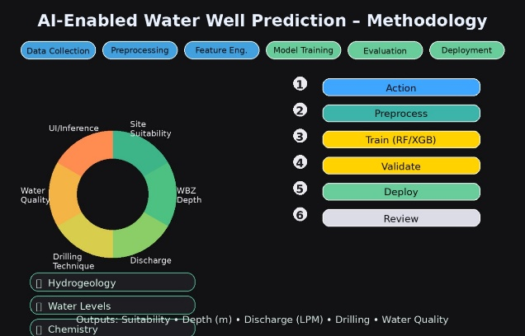
Fig 1: AI-Enabled Water Well Prediction
- Data Preprocessing
After this, raw data is cleaned and processed to achieve quality and consistency. The gaps are dealt with using the interpolating or imputation methods. Outliers are eliminated in order to avoid model biases. Normalization of any dataset sets all the parameters to similar levels. The geographic coordinates are equated to a shared space reference system that provides spatial precision. The derived parameters will include slope, drainage density, rainfall variation index and ground water recharge potential that will be created by using feature engineering and which will enhance the predictive capacity of the model.
- Feature Selection
Feature selection methods are employed mainly for improving the efficiency of models by reducing redundancies. The correlation analysis identifies highly correlated variables, while algorithms such as RFE or PCA have been used in the extraction of the most important predictors. Features that are very relevant include rainfall, soil permeability, elevation, and aquifer type, since these are the ones that mostly control well productivity and occurrence.
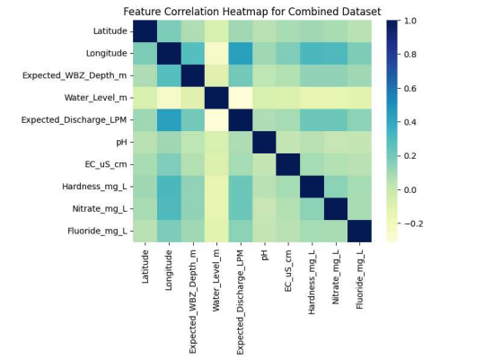
Fig 2:Feature Correlation Heatmap for Combined Dataset
- Model Development
Once preprocessed, the cleansed data is deployed in a machine learning modeling practice. Other examples of algorithms that are tested to identify the best model that may result in improved prediction of ground water potential or well yield include Random Forest, Gradient Boosted Decision Trees, and Artificial Neural Networks. The input of the model is a number of selected features and the output variable is the probability of success in drilling a water well or the rate at which the well in question is likely to yield. Data used in the study is split into training, validation, and testing sets in the proportion of 70:15:15 without introducing bias during the analyses of models.
- Model Evaluation
Most of the statistical measures are used to measure model performance. The performance measures in the case of regression-based outputs are RMSE, MAE and R2. Classification outputs are regarded in terms of accuracy, preciseness, recall, and F1-score. There is also cross-validation that makes sure that the model performs well on the data that it has not previously encountered. The most successful model is chosen according to the predictive accuracy and calculation efficiency.
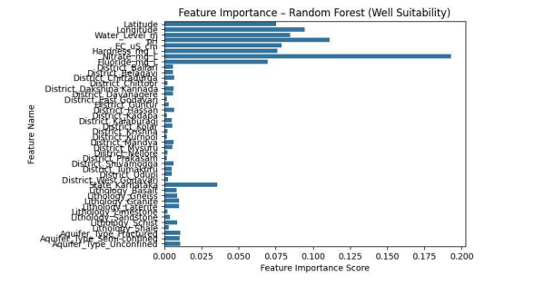
Fig 3: Feature Importance-Random Forest
- Deployment and Visualization
These models are then implemented in a web based or GIS integrated environment whereby the users are capable of using spatial coordinates or environment parameters in order to obtain the predictions of water wells. Model results have been developed using heat maps, contour plots and 3D groundwater potential maps. This enables decision makers, local government and engineers to identify appropriate location of wells with greater confidence in a more comprehensive manner.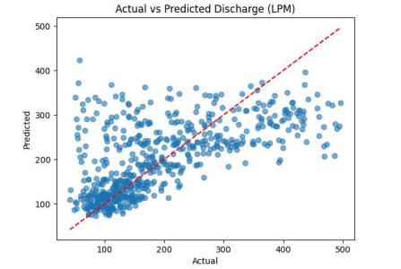
Fig 4: Actual vs Predicted Discharge(LPM)
- Continuous Improvement
The new well information, rainfall data and remote sensing data constantly update the deployed system to maintain its accuracy as the climatic or other environmental conditions alter. Periodically the model retraining is implemented and new datasets are added. Feedbacks of field surveys and user reviews contribute to the process to make some adjustments to the model and achieve better reliability in prediction.

IV. Machine Learning Models

The suggested system is based on a multi-model architecture according to which prediction tasks are performed by different optimized machine learning models depending on the nature of the output variable.
- Site Suitability Prediction:
Random Forest Classifier is utilized to estimate whether a location can be drilled to get a water well. Random Forest is selected due to its effectiveness on heterogeneous tabular hydrogeological data and the ability to offer high levels of generalization even under non-linear feature-relationship. Suitability label imbalance Class imbalance in suitability labels is addressed by setting class_weight=balanced to classify minority classes better.
- Depth Prediction:
An XGBoost Regressor model is predicted to give the predicted depth of the water bearing zone (WBZ). Depth is a continuous numerical variable, and thus regression-estimation can make more efficient depth prediction. It is desirable as XGBoost has better regression on structured environmental data and is a boosting-based learning algorithm.
- Discharge Prediction:
An XGBoost Regressor is also used to predict the expected groundwater discharge or yield. Since discharge output is a continuous variable, it is better to make use of regression modeling than the concept of classification. The reason why XGBoost was chosen is that the model handles large interaction of features very well and it minimizes overfitting through controlled boosting.
- Drilling Technique Prediction:
The choice of appropriate drilling method can be discussed as the categorical classification problem and represented in the form of a Random Forest Classifier. The various drilling techniques depend on the lithology, fracture type, and nature of formations. Random Forest delivers consistent categorical decision limits as well as is efficient in geological variables.
- Water Quality Prediction:
A prediction of the groundwater quality category (Good / Moderate / Poor) is carried out with the help of a Random Forest Classifier. Water quality labels are categorical in nature and hence categorization is applied.
- Model Evaluation:
The evaluation of classification models (Site Suitability, Drilling Technique, Water Quality) is measured on Accuracy and Macro F1 Score since Macro F1 balances performance by class in unbalanced multi-class evaluation. R 2, Mean Absolute error (MAE) and Root Mean Squared error (RMSE) are used to assess the quality of regression models (Depth and Discharge).
- Reason for Model Choice:
Random Forest was selected on classification tasks because it is robust, resistant to noise and good performance on mixed categorical and numerical hydrogeological data. XGBoost is chosen to undertake regression tasks due to the fact that it can model continuous dependent variables with a high level of precision, and also better generalization using gradient boosted ensemble learning.

V. PREDICTION RESULTS

The trained models were then deployed into the Streamlit application and evaluated with several inputs on live locations. Each test site had all five outputs simultaneously Site Suitability, estimated Water Bearing Zone depth, predicted discharge (LPM), recommended drilling method and expected water quality produced by the system.
As an illustrative, in part one sample output, the model predicted the site to be Suitable to drill, estimated depth of the site was approximately 166 meters and the discharge rate was apparently 181 LPM and proposed the Down the sHole method of drilling. The water quality prediction however showed Poor which meant that the water would be treated before it could be used.
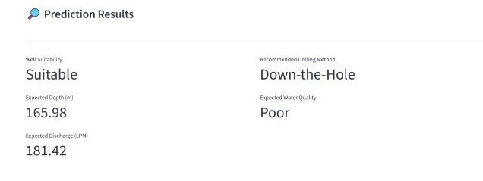
Fig 1 : Prediction Result of Down-the-Hole.

On another test run, the model has pointed out the site as Being Not Suitable although the discharge was quite high (approximately 303 LPM). In the given case, the model suggested Rotary Drilling, and the quality of water was presented as Moderate, pointing to more complicated underground circumstances.
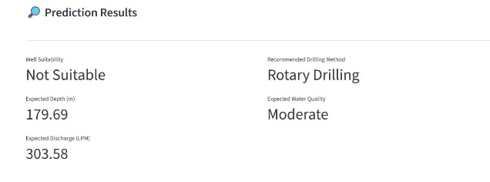
Fig 2 : Prediction Result of Rotary Drilling.

The model in the third sample case once again predicted the place to be Suitable, and a moderate amount (approximately 273 LPM) of discharge and prescribe Percussion Drilling. Still in this case, the water quality was Moderate.
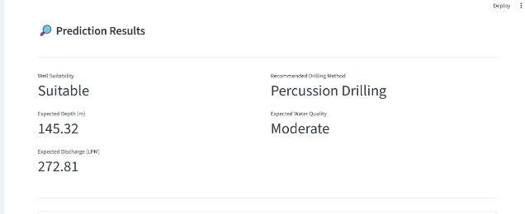
Fig 3 : Prediction Result of Percussion Drilling.

It is also evident in these examples that the proposed AI-based system will be in a position to intelligently discriminate between the locations of drilling that are appropriate and non-suitable, as well as offer realistic estimates of the depth, discharge, drilling methodology and quality of water. The forecasts are also consistent with geological behaviour, which means the high practicality and practical applicability of groundwater decision support.

Interpretation of the Prediction Result
In the chosen area of the Latitude 15.7711 and Longitude 78.0469 in Andhra Pradesh, the AI-based system identified that the area is Suitable to drill a new ground water well. This implies that the product of geology structure, indicators of aquifer formation as well as ground water quality at this stage are favourable to think of drilling wells.
The model approximates the Water Bearing Zone to exist at a depth of about 145.32 meters. This depth that is known prior to drilling is useful in minimizing uncertainties, strategizing the drilling exercise, and estimating the total expenditure and equipment required.
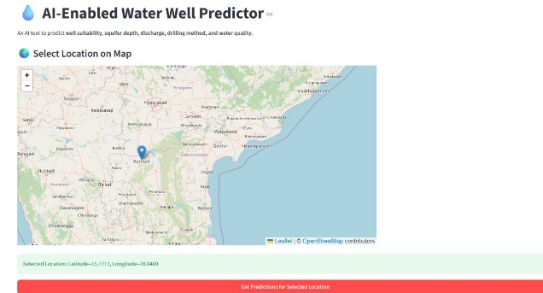

The estimated ground water discharge at this location will be approximately 279.43 Liters per Minute (LPM) indicating a moderate to good yield. Such amount of discharge indicates domestic consumption and small-scale agricultural usage can be reasonable supported by the well in case it is built.
On drilling technique, the system suggests that Auger Drilling would be the best drilling technique to be applied in this area. This has been recommended on the basis of the lithology type, approximated depth, aquifer qualities and other geological indicators, which make the process of drilling a lot safer and more efficient.
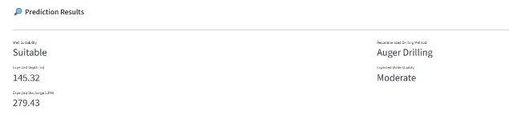

Lastly, the water quality in this location will be Moderate. This shows that, although the water would be usually good, some form of treatment or quality control would be recommended or otherwise according to the usage needs.
VI. CONCLUSION
Water is the blood of life and yet millions of people in the world are struggling to find safe and reliable sources of the commodity. Water wells still form the basis of community sustenance, and often, due to poor location, it is a squandering of time, money, and hope. The Water Well Predictor with AI project can be a good example of how technology can proceed with reducing such uncertainty. The system offers a more intelligent and data-based process of determining well location and managing groundwater resources through artificial intelligence and trends in geology and environment. This much and no more is in this work -technological innovation-but of directly helping farmers to grow their crops, to help families to have a safe drinking supply, and to give those communities, who wish to plan a better future, the means of doing so. Not only predicting in an accurate manner, but also showing us of sustainability-waying, this project recalls us of the need to be responsible in preserving the groundwater resources that will be benefited by the future generation. It is not a matter on algorithms and machines but hope, equity, and efficiency in the solution to one of the largest problems humanity will ever have to encounter. The AI Water Well Predictor is one of the very few examples of how science can contrast with the compassion and make technology not only the means of development, but the means of survival, and human dignity.
VII. REFERENCES
[1] K. Chen et al., “Integration of SBAS-InSAR-Derived Vertical Ground Motion with a Land Surface Model to Enhance Terrestrial Water Storage Estimation,” IEEE Journal of Selected Topics in Applied Earth Observations and Remote Sensing, vol. 15, pp. 2826–2835, 2022, doi: 10.1109/JSTARS.2022.3162228.
[2] G. May-Lagunes, V. Chau, E. Ellestad, L. Greengard, P. D'Odorico, P. Vahabi, A. Todeschini, and M. Girotto, “Machine learning-based groundwater level forecasting: A study focused on California’s Central Valley,” Journal of Hydrology X, vol. 21, 2023, 100161, ISSN 2589-9155, doi: 10.1016/j.hydroa.2023.100161.

[3] S.-B. Kim et al., “Forest Soil Moisture Retrieval Using Airborne L-Band SAR Mimicking NISAR Capabilities,” IEEE Journal of Selected Topics in Applied Earth Observations and Remote Sensing, vol. 18, pp. 7364–7373, 2025, doi: 10.1109/JSTARS.2025.3544095.
[4] A. Mosavi, F. S. Hosseini, B. Choubin, M. Goodarzi, and A. A. Dineva, “Mapping Groundwater Salinity Vulnerability through Ensemble Classifiers and Bayesian Machine Learning Techniques,” IEEE Access, vol. 8, pp. 145564–145576, 2020, doi: 10.1109/ACCESS.2020.3014908.
[5] N. Iqbal et al., “A Borehole-Based Correlation and Difference Mechanism Model for Predicting Groundwater Levels for Sustainable Hydrologic Management,” IEEE Access, vol. 9, pp. 96092–96113, 2021, doi: 10.1109/ACCESS.2021.3094735.
[6] B. Aslam, A. Maqsoom, A. H. Cheema, F. Ullah, A. Alharbi, and M. Imran, “Hybrid Machine Learning and Data Mining Framework for Water Quality Management Using Indexing Strategies,” IEEE Access, vol. 10, pp. 119692–119705, 2022, doi: 10.1109/ACCESS.2022.3221430.
[7] F. Fan, H. Ghorbani, and R. A. E. Radwan, “Groundwater Level Forecasting Using Classical and Deep Learning Methods,” Frontiers in Environmental Science, vol. 12, 2024, doi: 10.3389/fenvs.2024.1291327.
[8] E. Hussein, C. Thron, M. Ghaziasgar, A. Bagula, and M. Vaccari, “Application of Machine-Learning Techniques for Groundwater Prediction,” Algorithms, vol. 13, no. 11, p. 300, 2020, doi: 10.3390/a13110300.
[9] P. Shu, R. W. Aslam, I. Naz, B. Ghaffar, D. Kucher, A. Quddoos, D. Raza, M. Abdullah-Al-Wadud, and R. M. Zulqarnain, “Enhancing Groundwater Quality Assessment and Urban Environmental Monitoring Using Deep Learning-Based Remote Sensing Image Super-Resolution,” IEEE Journal of Selected Topics in Applied Earth Observations and Remote Sensing, pp. 1–20, 2025, doi: 10.1109/JSTARS.2025.3548010.
[10] S. Ebrahimi, S. Haji-Aghajany, Y. Amerian, and M. Tasan, “EvapoDeep: A Dual-Layer Deep Learning System Incorporating GNSS Observations for Predictive Evapotranspiration Analysis,” IEEE Journal of Selected Topics in Applied Earth Observations and Remote Sensing, vol. 18, pp. 17265–17280, 2025, doi: 10.1109/JSTARS.2025.3586407.
[11] X. Yang and Z. Zhang, “Meta-Learning-Driven CNN-LSTM Model for Groundwater Level Forecasting in the Middle and Lower Heihe River Basin, China,” Water, vol. 14, no. 15, p. 2377, 2022, doi: 10.3390/w14152377.
[12] M. Dhapre, S. Jadhav, D. Das, J. Khan, Y. Kim, S. Chiao, and T. Danielson, “Comprehensive Review of Machine Learning Applications in Groundwater Monitoring,” Environmental Modelling & Software, vol. 192, 2025, 106549, ISSN 1364-8152, doi: 10.1016/j.envsoft.2025.106549.

